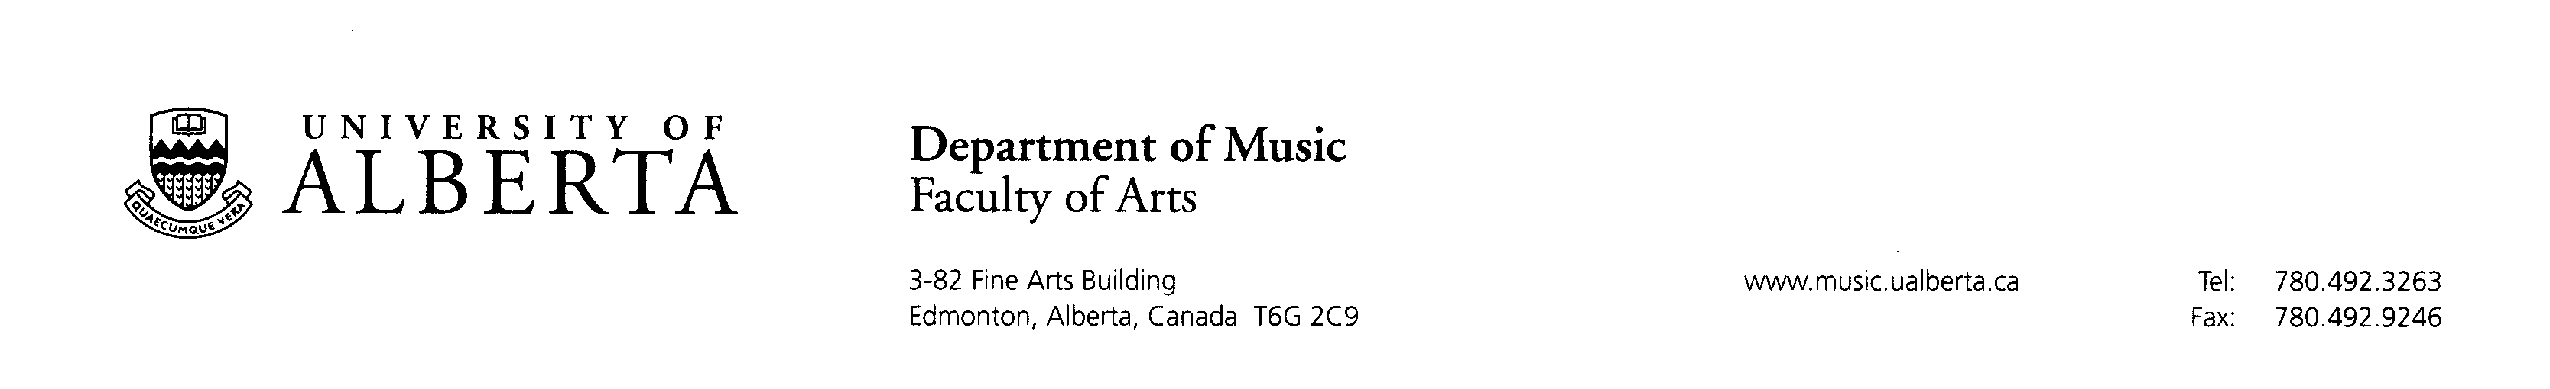

June 30, 2025

I am delighted to write in support of Nasim Ahmadian’s application to the Elahé Omidyar Mir-Djalali Postdoctoral Fellowship in Iranian Studies at the University of Toronto.

I have known Nasim since 2016. She came to the University of Alberta with a BA in Iranian Music Performance and an MA in Ethnomusicology from the University of Tehran. While still in Iran, she founded the Nasim Ensemble (2011-2016), an ensemble that won Third Prize in the International Fajr Festival in 2013-14. She is a professional performer on the Santur (hammer dulcimer) and made contributions while in Iran to the early pedagogy of traditional Iranian instruments in the education curriculum of primary schools. This pedagogical and performance background is at the foundation of her dissertation, which is a bold exploration of the aesthetics of sorrow in Persian traditional music, with special emphasis on the pedagogy of affect. This topic takes Nasim to the literary roots of Persian music and the Sufi mystical traditions of which it is tributary. Besides the historical, literary, and religious-mystical perspective, Nasim explores the pedagogical aspect of cultural transmission by delving into her own musical formation in the study of improvisation, as well as collecting records, through interviews, of the musical formation of her teachers, providing in this way a generational continuity of tradition within a context of constant socio-political upheaval. As such, her work provides a unique frame, both personal and historical, of great originality and interest in ethnomusicological literature.

Nasim defended her dissertation in December 2023 and is currently working on a book project on the themes of her dissertation. Since 2016, she has maintained an enviable record of accomplishments. Her research publications include a forthcoming film review on feminism in Iranian society (2023); a book chapter on the aesthetics of sorrow in an edited volume (2023) and review of Farzaneh Hemmasi’s book-length study on popular music in Iran which was published in the Journal of World Popular Music (2021). She has presented in major conference venues both nationally and internationally, including the Society for Ethnomusicology (SEM) in 2018 and 2020, 2023; the annual Analytical Approaches to World Music conference (Thessaloniki, 2018), the Canadian Society for Traditional Music (2018) among others. Her forthcoming contributions include a book review on Amir Hossein Pourjavadi’s historical study of Persian music (in Yearbook for Traditional Music); an article on Ta’zieh ritual and the aesthetics of sorrow (in MusiCultures, special volume on ReSounding Loss: Music, Grief, and Culture); and a hermeneutic and cultural-historical study of the song “Morgh-e Sahar” (in Musico-Literary Contexts: Signs, Sounds, and Stories).

This year, Nasim was appointed for a three-year term as Book Review Co-Editor of Ethnomusicology – a significant appointment and important vote of confidence from the flagship journal of the discipline. Indeed, publication has been integral to Nasim’s trajectory as a graduate student, where she was a key participant, first as Editor in Chief in the graduate student online journal Intonations at the University of Alberta, and subsequently she as co-Editor in Chief for Music alongside fellow co-Editors in the departments of Drama and Art and Design from 2019-2021. In that capacity she laid much of the groundwork for furthering the Journal’s mandate to explore cross-disciplinary synergies in the Fine and Performing Arts. In addition, she has served as Associate Editor for the University of Iowa’s Journal of Islamic and Middle Eastern Multidisciplinary Studies (2018-19).

In every possible way, Nasim has shown herself to be an emerging scholar at the highest possible level. As a colleague, Nasim is meticulous, congenial, and excels in collaborative and interdisciplinary work. Her teaching contributions at the University of Alberta have included Principal Instructor for Introduction to Ethnomusicology; Lecturer for Bibliography and Methods of Research for graduate and undergraduate students as well as an original course on Persian Art Music. Her research interests are vast but held together consistently with the common threads of pedagogy, performance, cultural history, tradition, and interpretive arts in music and film.

In the years I have known her in my capacity as teacher, supervisory committee member, mentor, and colleague, I have found Nasim to be a consummate professional and an attentive and dedicated scholar of great originality and promise. The monograph she is preparing based on her dissertation “The Sweetness of Sorrow: Aesthetics, Affect, and Pedagogy in Iranian Classical Music,” is a brilliant work, at the same time erudite and intimate in style, and is certain to become a landmark in Iranian Studies. I recommend her warmly and without reservation as an important scholar worthy of the honour of being the recipient of the Elahé Omidyar Mir-Djalali Postdoctoral Fellowship.
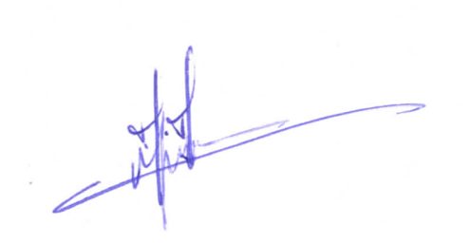
Maryam A. Moshaver
Associate Professor of Music Theory
University of Alberta

